Do You Want to Eat That?!
A Practical Investigation into Enzymes

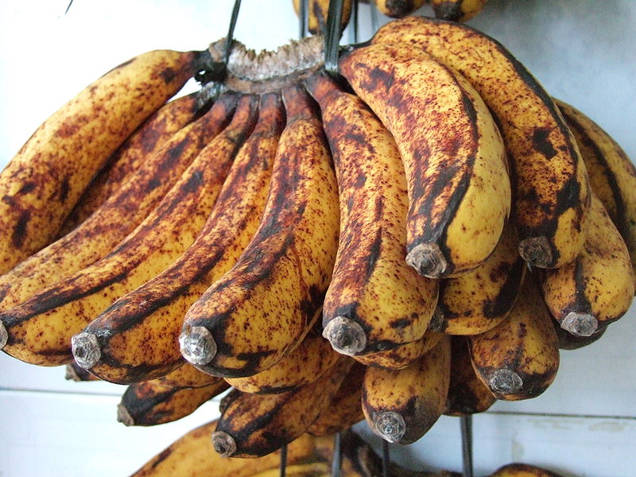
Would you buy these bananas in the grocery store? Why or why not?

Part 1: Question: Why does fruit turn brown when you cut it open?
Think-pair-share
- Write a list of fruits that turn brown when you cut them open.
- What do you think is causing the fruit to turn brown?

Part 2: Research!
- You decide that you need to gather some more information to answer your questions so you do some research. You come across a write up that catches your attention.
“Enzymic browning in potatoes…” by J.M. Busch
- It’s a pretty tough read so you decide to look up some vocabulary first.
  - Terms to know:

Oxidation
Catalyze
Enzymic
- Next you decide that these articles are a little over your head so you decide to just focus on the information you’re after so you don’t get distracted and lost by all this “science mumbo jumbo”. You decide to focus on 3 things from the article: the cause of browning, the benefits of browning, and also the negatives of browning.

Directed Note Taking

Directions: Record notes containing the most important information relevant to the guiding question.
“Enzymic browning in potatoes”

Guiding Question: Why does fruit brown and what is causing fruit to brown after cutting?

Check Relevant Categories

Paragraph | Notes | Cause of browning | Benefit of browning | Negative of browning
Collaborative Work: After completing your chart, be prepared to compare your notes with others.

Enzymic browning in potatoes: a simple assay for a polyphenol oxidase catalysed reaction [Excerpt]
J.M. Busch*
Animal and Food Sciences Division, Lincoln University, P.O. Box 84, Canterbury, New Zealand
Lexile 1330L

Background

Many fruits and vegetables turn brown when cut or damaged surfaces are exposed to the air, with the reaction showing most clearly on light-coloured flesh. This browning occurs due to the oxidation and dehydrogenation of colourless polyphenols present in the plants. The initial reaction catalysed by polyphenol oxidase (an enzyme) and produces reddish-brown o-quinones. These are highly reactive, and so they subsequently undergo a series of non-enzymic reactions [4,5] to yield insoluble black-brown melanin pigments (Fig. 1).

Polyphenol oxidase is a very important enzyme for food chemists and processors because its action leads to major economic losses in fresh fruits and vegetables such as potatoes, lettuce and other leafy vegetables, apples, grapes, bananas and many tropical fruits [6]. Up to one-half of some tropical fresh fruits are lost because of browning [7]. Potential purchasers show consumer resistance to the dark colour of the damaged products, the off-tastes in juices and vegetables, and the resulting changes in texture. This reaction is, however, exploited in the fermentation of tea leaves, coffee beans, cocoa and tobacco, and in the colour of dried prunes, dates and raisins [7].

The enzyme is located in the plastids of plant cells and the phenolic substrates are stored in the vacuoles. This physical separation prevents any oxidation of the phenolics in the undamaged living tissues [3]. The separation can be lost as a result of damage to the cell during harvesting (unintentional) and processing (intentional).
Oxidation of the phenolics by polyphenol oxidase (PPO) then begins.

The functions of PPOs in higher plants are not fully known but they are thought to play a key part in the plant's defense mechanism against disease causing micro-organisms and insect attack [7]. When microbial infection occurs the cell integrity is broken and the enzymic reaction takes place. An impervious scab of melanin forms and this acts as a physical anti-microbial barrier [3]. The quinones formed during the reaction are known to denature proteins in the invading microorganisms and the polymeric phenols complexes can act as inhibitors of microbial growth [3].

http://onlinelibrary.wiley.com/doi/10.1016/S0307-4412(99)00033-3/pdf

Part 4: More Research!

- During your research you came across another article that you found interesting. Again you’re slightly intimidated by the language of the article so you decide to just focus on answering your questions.

- Directions: Record notes containing the most important information relevant to the guiding question.
“Replacing sulphites in food” Food Trade Review

Guiding Question: Why are sulphites used in food and what are the risks, benefits and alternatives to sulphite use?

Check Relevant Categories

Paragraph | Notes | Use of Sulphites | Benefits of sulphite use | Risks of sulphite use | Alternatives to sulphites
- Collaborative Work: After completing your chart, be prepared to compare your notes with others.

Replacing sulphites in food.
Food Trade Review
Lexile Level 1200L

Sulphur dioxide and sulphites are incorporated into many food products. Their main activity is in the prevention of enzymatic browning in foods, especially fruits and vegetable products. In addition, they have strong antimicrobial activity, and are widely used as preservatives. However, there are several downsides to the widespread use of sulphites - they strongly reduce vitamin Bl uptake from food and pose risks for allergy sufferers and asthma patients.

Campden BRI is one of nine European partners in a European Union-funded project aiming to find replacements for sulphites in food and drinks.

Craig Leadley, Campden BRI's New Products and Technologies Manager, explains: "The aim of the SO2SAY project is to develop a strategy to make application of sulphur dioxide or its releasing salts unnecessary for almost all food products. This is an ambitious target, but could significantly affect the formulation and processing of a wide range of foodstuffs. An important requirement will be the unchanged sensory quality and shelf-life of products produced without sulphur dioxide treatment.

Three approaches will be investigated to allow the elimination of sulphur dioxide: enzyme inactivation to prevent enzymatic browning; development of plant extracts containing secondary plant metabolites high in antioxidative capacity (e.g. plant polyphenols) and antimicrobial activity; and processing and packaging under an oxygen reduced atmosphere."

The two-year project is due to run until the end of 2010.
Contact Campden BRI on tel 01386 842000 or visit campden.co.uk

COPYRIGHT 2010 Food Trade Press Ltd.
No portion of this article can be reproduced without the express written permission from the copyright holder.
Copyright 2010 Gale, Cengage Learning. All rights reserved.

Part 6: Peer Discussion

- Sulphite use as a preservative in foods has some risks associated with it application. Is it worth the risks to continue to apply it to our food to prevent browning?

- Do you want to eat brown or bruised foods like fruits, vegetables, or even shrimp?

- Should sulphite alternatives be investigated? Why?

Part 7: Explanation: CER
Write a paragraph explanation regarding the safety of sulphite use as a preservative (to prevent browning) in foods.
- Claim: Decide whether or not sulphite use is a health hazard to our society.
- Evidence: Cite evidence from your article.
- Reasoning: Discuss how that evidence supports your claim.
Question | Is sulphite use as a preservative on our food a health hazard to our society?
Claim
Evidence
Reasoning

Review
- You now know that browning is caused by the enzyme polyphenol oxidase which is activated by oxygen in the air upon cutting or bumping. You’re not happy that potentially harmful sulphites are currently being used to preserve your food so you decide to investigate alternative methods to prevent browning.

Part 8: Brainstorming
- What kind of molecule is polyphenol oxidase?

- What is it called when this type of molecule changes shape or stops working (loses its function)?

- What are some ways that these kinds of molecules can be stopped from working?
Part 9: Experimental Design- Investigating Your Claim!
- You happen to have some potatoes/apples lying around that you can experiment with.
- Your Job:
  - Hypothesize at least 1 sulphite alternative (what denatures enzymes) that will prevent browning and be safe to use on potatoes/apples.
  - Design an experiment to test your hypothesis.
*Use the “Steps to Inquiry” planning sheet to help guide you. Make sure to design your conclusion in the CER format. *

